**A**

**MINI PROJECT REPORT ON**

**LPG GAS DETECTION AND ACCIDENT PREVENTION SYSTEM**

**SUBMITTED TO SAVITRIBAI PHULE PUNE UNIVERSITY, PUNE**

**IN THE FULFILLMENT OF THE REQUIREMENTS**

**FOR THE COMPLETION OF MINI PROJECT**

**OF**

**THIRD YEAR ENGINEERING**

**IN**

**ELECTRONICS & TELECOMMUNICATION**

**BY**

**Tushar Joshi Exam No. T190233123**

**Suhas Khobragade Exam No. T190233145**

**Omkar Bhise Exam No. T190233189**

**UNDER THE GUIDANCE OF**

S.A.SHIRSAT



**DEPARTMENT OF ELECTRONICS & TELECOMMUNICATION ENGINEERING**

**SINHGAD COLLEGE OF ENGINEERING**

**S. No. 44/1, OFF SINHGAD ROAD,**

**VADGAON BK, PUNE – 411041**

**APRIL 2022**



**CERTIFICATE**

This is to certify that the Mini Project entitled

**"LPG GAS DETECTION AND ACCIDENT PREVENTION SYSTEM”**

**Submitted By**

**Tushar Joshi**

**Suhas Khobragade**

**Omkar Bhise**

is a bonafide work carried out by them under the supervision of Dr. S.A.Shirsatand it is approved for the partial fulfillment of the requirements of T.E. E&TC Engineering submitted to Savitribai Phule Pune University, Pune.

The Mini Project work has not been earlier submitted to any other institute or university for the award of degree or diploma.

**Dr. S.A.Shirsat Dr. M. B. Mali Dr. S. D. Lokhande**

Guide Head Principal

Department of E &TC Department of E &TC SCOE, Pune

**Place:** Pune

**Date:**

**ACKNOWLEDGEMENT**

We are feeling very humble in expressing our gratitude. It will be unfair to bind the precious help and support which we got from many people in few words. But words are the only media of expressing one’s feelings and my feeling of gratitude is absolutely beyond these words. It would be my pride to take this opportunity to say the thanks.

Firstly, we would thank our beloved guide **Dr. S. A. Shirsat** for her valuable guidance, patience and support; She was always there to force us a bit forward to get the work done properly and on time. She has always given us freedom to do mini project work and the chance to work under her supervision.

We would like to express our sincere thanks to **Dr. S. A. Shirsat**, Mini Project Coordinator, Department of E&TC, for her constant encouragement in the fulfillment of the mini project work. We would also like to express our sincere thanks to **Dr. M. B. Mali, Head,** Department of E&TC for his co-operation and useful suggestions. We would also like to thank **Dr. S. D. Lokhande, Principal, Sinhgad College of Engineering.** He always remains a source of inspiration for us to work hard and dedicatedly.

It is the love and blessings of our families and friends which drove us to complete this project work.

Thank you all!

**Tushar Joshi**

**Suhas Khobragade**

**Omkar Bhise**

**ABSTRACT**

The usage of the gas brings great problems in the domestic as well as working places. The inflammable gas such as Liquidized petroleum gas (LPG), which is excessively used in the house and at work places. The leakage of the gas causes destructible impact to the lives and as well as to the heritage of the people. So, by keeping it in the concept of the project we have determined to develop an examining system which finds the leak of LPG gas and protects the work places by taken correct precaution at correct time.

Home fires have been taking place frequently and the threat to human lives and properties is growing in recent years. LPG is highly inflammable and can burn even at some distance from the source of leakage. Most fire accidents are caused because of a poor-quality rubber tube or when the regulator is not turned off. The supply of gas from the regulator to the burner is on even after the regulator is switched off. By accident, if the knob is turned on results in the gas leaks. This project deals with the detection, monitoring and control system of LPG leakage. Using sevo motor the stove knob is automatically controlled.

**LIST OF FIGURES**

|  |  |  |
| --- | --- | --- |
| Figure No | Figure Description | Page No. |
| 2.1 | **LPG Consumption in India** | **6** |
| 3.1 | **Block Diagram of System** | **10** |
| 3.2. | **Arduino Uno** | **11** |
| 3.3 | **MQ 2 Gas Sensor** | **13** |
| 3.4 | **Servo Motor** | **13** |
| 3.5 | **Buzzer** | **14** |
| 3.6 | **DC Fan** | **15** |
| 3.7 | **IRF530 MOSFET** | **15** |
| 3.8 | **Sensitivity Characteristics of the Gas Sensor** | **16** |
| 3.9 | **Circuit Diagram of system** | **18** |
| 3.10 | **Interfacing Diagram of MQ 2 Gas Sensor** | **18** |
| 3.11 | **Interfacing Diagram of Servo Motor** | **19** |
| 3.12 | **Flow Chart** | **19** |
| 4.1 | **Simulation Result** | **22** |
| 4.2 | **Hardware Result** | **23** |

**LIST OF TABLES**

|  |  |  |
| --- | --- | --- |
| **Table No** | **Table Description** | **Page No.** |
| **3.1** | **Comparison of different microcontrollers** | **11** |
| **3.2** | **Comparison of different Gas Sensors** | **12** |

**CONTENTS**

CHAPTER 1: INTRODUCTION

1.1 Introduction

1.2 Problem Statement

1.3 Platform Used

CHAPTER 2: LITERATURE REVIEW

2.1 Recent Trends

2.2 Literature Survey

CHAPTER 3: DESIGN AND DEVELOPMENT

3.1 Block Diagram

3.2 Circuit Diagram and Description

3.3 Calculations

3.4. Flow Chart

3.5. Algorithm

CHAPTER 4: RESULTS AND DISCUSSIONS

Chapter 4: Result and Discussions

4.1 Simulation Results, (Snapshot)

4.2 H/W results

4.3 Difference between simulation and actual hardware

CHAPTER 5: CONCLUSIONS AND FUTURE SCOPE

Chapter 5: Conclusions & future Scope

5.1 Conclusion based on result

5.2. Advantages

5.3 Disadvantages

5.4 Future Scope

CHAPTER 6: REFERENCES

Appendix

Datasheet

**CHAPTER 1**

**INTRODUCTION**

**1.1 INTRODUCTION**

Gas leakages are a common problem in households and industries. If not detected and corrected at the right time, it can also be life threatening. Unlike a traditional gas leakage alarm system which only senses a leakage and sounds an alarm, the idea behind our solution is to turn off the main power supply and gas connection as soon as a gas leakage is detected apart from sounding the alarm. There are mainly two units, in this circuit: sensor unit, microcontroller unit. For detecting dangerous & flammable gas leaks in any closed environment such as a car, house, service station or storage tank, a gas sensor is used which detects natural gas, LPG and coal gas. This sensor can also be used to sense other gases like iso-butane, propane and even cigarette smoke. This unit can easily be incorporated into an alarm unit to sound an alarm.

Bhopal gas tragedy was an example of gas leakage accident in India. This was world’s worst gas leakage industrial accident. Gas leakage detection is not only important but stopping leakage is equally essential. Unlike a traditional gas leakage alarm system which only senses a leakage and sounds an alarm, the idea behind our solution is to turn off the main power supply and gas connection as soon as a gas leakage is detected apart from sounding the alarm.

**1.2 PROBLEM STATEMENT**

Gas leakage is a major problem with industrial sector, residential premises etc. One of the preventive methods to stop accident associated with the gas leakage is to install a gas leakage detection kit at vulnerable places. The aim of this project is to present such a design that can automatically detect,

alert and control gas leakage.

Some people have low sense of smell, may or may not respond on low concentration of gas leakage. In such a case, gas leakage security systems become an essential and help to protect from gas leakage accidents. A number of research papers have been published on gas leakage security system. Embedded system for Hazardous gas detection and Alerting has been proposed where the alarm will be activated immediately, if the gas concentration exceeds normal level. There have been many accidents that have been caused due to leakage of gas and have caused loss of life and property. Gas leakage detection is not only important but stopping leakage is equally essential. This project aims for a cost effective and highly accurate system, which not only detect gas leakage but also alert (Beep) and turn off the gas supply as well as turn off main power and gas supplies. In order to provide high accuracy gas sensor MQ 2 has been used.

**1.3 PLATFORM USED**

The Proteus Design Suite is a proprietary software tool suite used primarily for [electronic design automation](https://en.wikipedia.org/wiki/Electronic_design_automation). The software is used mainly by electronic [design engineers](https://en.wikipedia.org/wiki/Design_engineer) and technicians to create [schematics](https://en.wikipedia.org/wiki/Schematic) and electronic prints for manufacturing [printed circuit boards](https://en.wikipedia.org/wiki/Printed_circuit_board).

**CHAPTER 2**

**LITERATURE REVIEW**

**2.1 RECENT TRENDS**

The number of deaths caused by cooking gas cylinder and stove bursts in the state last year has been pegged as the second highest in the country, after Gujarat. The latest statistics of National Crime Records Bureau (NCRB) show that 586 people died in Tamil Nadu because of explosion of cooking gas cylinders.

Gujarat registered 735 such deaths.

Tamil Nadu tops the southern states in the category, far above Andhra Pradesh (426), Karnataka (386) and Kerala (52). This means more than 10 people in Tamil Nadu die every week because of gas cylinder explosions. On the whole, there have been 632 such accidents last year. In Chennai, 91 people died in 96 gas cylinder accidents. Statistics show that 481 women lost their lives in cylinder  explosion. So there is a need of a safety measure to avoid such accidents. Fig 2.1 shows LPG Consumption in India.

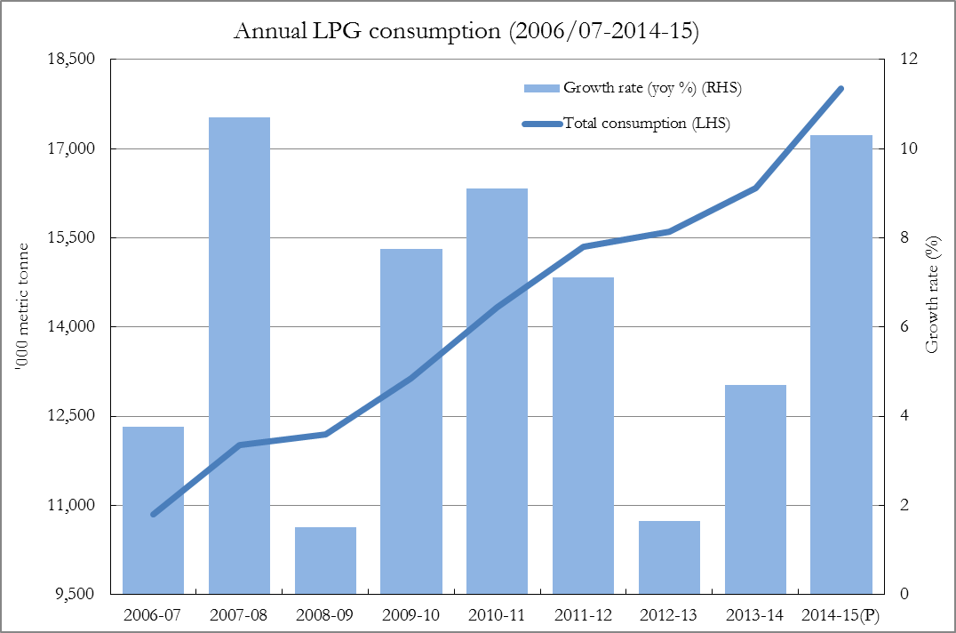  
**Fig. 2.1 LPG Consumption in India**

**2.2 LITERATURE SURVEY**

This paper represents a prototype for wireless gas leakage systems that can be used mainly in household safety and many other applications in the industry and environment. For example it can be used in facilities where gas cylinders are stored. Any leakage can be recognized through the receiver module. The use of a sensor that is sensitive to small changes of concentration provides an excellent tool to detect a gas leak as it can detect small concentrations down to 100 ppm. The sensor used in the system may be affected by the surrounding temperature and humidity, therefore calibrating the system at the start up of operation was done to determine the zero set point. The sensitivity of the entire system can be adjusted by changing the load resistor of the sensor which provides the flexibility to externally calibrate the system to avoid any false alarms. The algorithm used in the microcontroller system depends on detecting the change of gas concentration levels and therefore the output voltage of the sensor. This gives the system the advantage of detecting leaks of the gases that the sensor detects. Measuring the actual concentration of a certain gas can not be easily done with this sensor, since it can detect many gases at the same time and has a non-linear sensitivity curve. The proposed system can be supplied with a switching circuit along with an electromechanical solenoid valve that can disable.**[1]**

In this paper author’s have they described a new approach for gas leakage detection system at a low concentration. The leakage is detected with the help of MQ-6 Gas Sensor. The sensor sends a signal to microcontroller. In the next step microcontroller sends an active signal to other externally connected devices. The efficiency and memory of the microcontroller can be increased if Philips Microcontroller is used in place of AT89C51. Multiple SMS can be sent by changing programming GSM Module. To change the SIM Card we have to make changes in program.**[2]**

This paper presents a research work which is easy to use and gives remote indication to the user. The sensor used in this Research Work has excellent sensitivity combined with a quick fast response time. The system is highly reliable, tamper-proof and secure. In the long run the maintenance cost is very less when compared to the present system. It is possible to get instantaneous results and with high accuracy.**[3]**

In this research paper authors have proposed the leakage detection and real time gas monitoring system. In this system, the gas leakage is detected and controlled by means of turn of the power supply and gas valve. At the end, when the gas leakage is successfully stopped then with the help of reset button the whole system is made to reach its initial stage. The MQ-6 Gas Sensor is a semiconductor type gas sensor which detects gas leakage by comparing the concentration of ethanol which is present as a mixture in the LPG with air. It then gives analog voltage as output.**[4]**

The aim is to develop a gas leak detection and location system for the production safety in Petrochemical Industry. The system is based on Wireless Sensor Networks (WSN); it can collect the data of monitoring sites wirelessly and sent to the computer to update values in the location software. Consequently, it can give a real-time detective of the potential risk area, collect the data of a leak accident and locate the leakage point. However the former systems can not react in time, even cannot obtain data from an accident and locate accurately. The paper has three parts, first, gives the overall system design, and then provides the approaches on both hardware and software to achieve it**.[5]**

**CHAPTER 3**

**DESIGN AND DEVELOPMENT**

**3.1 BLOCK DIAGRAM OF GAS DETECTION AND ACCIDENT PREVENTION SYSTEM**

Fig.3.1 shows the block diagram of gas detection and accident prevention system**.**

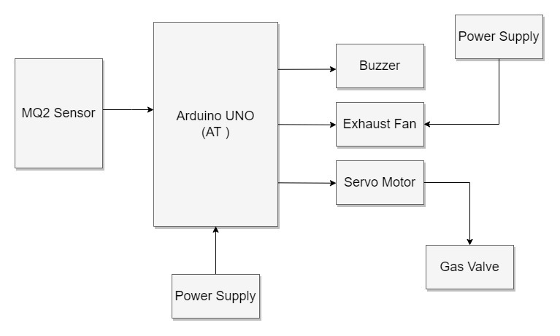

**Fig. 3.1 Block Diagram of gas detection and accident prevention system**

**Description :**

In the initial step, the gas leakage is detected by the gas sensor MQ-2. This detects the gas leakage and gives the signal to the microcontroller. After that in second step the microcontroller receive the signal and it sends activation signals to other external devices attached with it. Such as buzzer. In the last step, many tasks have been performed such as buzzer activates simultaneously and cut signals to gas valve and relay. As a result gas supplies turn off. At the end, when the gas leakage is successfully stopped then with the help of reset button the whole system reached to the initial stage.

**3.2 SELECTION CRITERIA OF COMPONENT**

**3.2.1 Microcontroller**

Comparison of different microcontrollers is shown in Table 3.1.

**Table 3.1 Comparison of different microcontrollers**

|  |  |  |  |
| --- | --- | --- | --- |
| **Parameter** | **Arduino Uno** | **Arduino Mega 2560** | **Arduino Micro** |
| **Analog Pins** | 6 | 16 | 12 |
| **Digital I/O Pins** | 14 | 54 | 20 |
| **Processor** | ATmega328P | ATmega2560 | ATmega32U4 |
| **Clock Speed** | 16MHz | 16Mhz | 16Mhz |
| **Flash Memory (kB)** | 32 | 256 | 32 |
| **SRAM (kB)** | 2 | 4 | 2.5 |
| **Digital I/O Pins** | 14 | 54 | 20 |

**Arduino Uno :**

Arduino UNO is a low-cost, flexible, and easy-to-use programmable open-source microcontroller board that can be integrated into a variety of electronic projects. This board can be interfaced with other Arduino boards, Arduino shields, Raspberry Pi boards and can control relays, LEDs, servos, and motors as an output.

Arduino UNO features AVR microcontroller Atmega328, 6 analogue input pins, and 14 digital I/O pins out of which 6 are used as PWM output. Fig.3.2 shows the Arduino Uno Board.

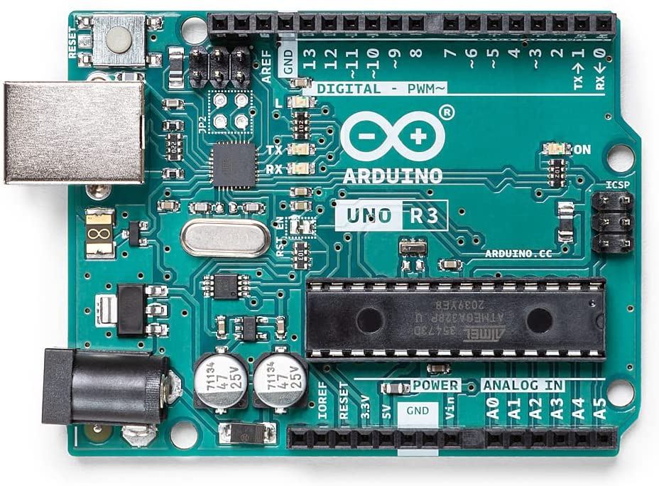

**Fig 3.2 Arduino Uno**

**Specifications :**

1. Operating voltage of Arduino Uno is 5V.
2. It has 14 digital I/O pins.
3. Flash memory of 32kb.
4. It has clock speed of 16MHz.

**3.2.2 GAS SENSOR**

Table 3.2 shows the comparison of Gas Sensors.

**Table 3.2 Comparison of Gas Sensors**

|  |  |  |
| --- | --- | --- |
| **Sensor** | **Detects** | **Voltage** |
| **MQ 2** | Methane, Butane, LPG, smoke | 5 V |
| **MQ 3** | Alcohol, Ethanol, smoke | 5 V |
| **MQ 4** | Methane, CNG Gas | 5 V |
| **MQ 5** | Natural gas, LPG | 5 V |
| **MQ 6** | LPG, butane gas | 5 V |
| **MQ 7** | Carbon Monoxide | Alternating 5 V and 1.4 V |
| **MQ 8** | Hydrogen Gas | 5 V |

**MQ 2 Gas Sensor :**

The MQ-2 Gas sensor can detect or measure gasses like LPG, Alcohol, Propane, Hydrogen, CO and even methane. The module version of this sensor comes with a Digital Pin which makes this sensor to work even without a microcontroller which comes in handy once you are only trying to detect one particular gas. Fig.3.3 shows the MQ 2 Gas Sensor.

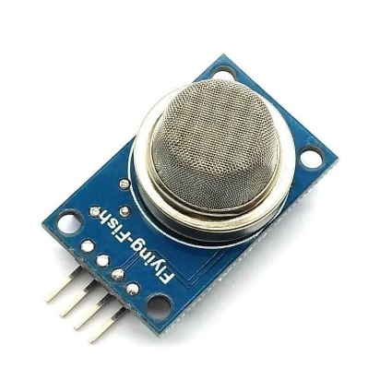

**Fig. 3.3 MQ 2 Gas Sensor**

**Specifications :**

1. MQ 2 gas sensor works on 5V DC.
2. It can detect LPG, Smoke, Alcohol, Propane, Hydrogen, Methane and Carbon Monoxide concentrations
3. It can detect gases in the concentration of range 200 to 10000ppm.

**3.2.3 SERVO MOTOR**

MG995 Servo Motor is a heavy-duty reliable servo motor. It is a low-power, cost-effective motor. MG995 is a dual shock-proof ball-bearing servo design with metal gear making it quite feasible for industrial production. The motor has a quick response and rotates at high speed. It comes with great holding power and a stable constant torque range. They are widely used in consumer robotics and hobby projects. MG995 is a durable double ball bearing servo motor. Fig.3.4 shows the servo motor.

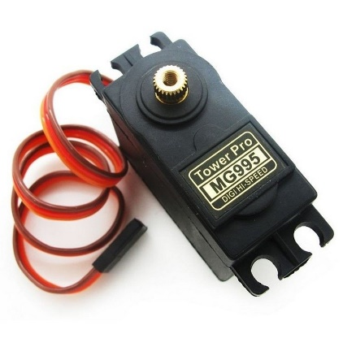

**Fig. 3.4 Servo Motor**

**Specifications :**

1. Operating voltage range: 4.8 V to 7.2 V
2. Rotational degree: 180º
3. No load operating current draw: 170mA
4. Fast control response

**3.2.4 BUZZER**

An audio signaling device like a beeper or buzzer may be electromechanical or [piezoelectric](https://www.elprocus.com/what-is-a-piezoelectric-material-working/) or mechanical type. The main function of this is to convert the signal from audio to sound. Generally, it is powered through DC voltage and used in timers, alarm devices, printers, alarms, computers, etc. Based on the various designs, it can generate different sounds like alarm, music, bell & siren.

t includes two pins namely positive and negative. The positive terminal of this is represented with the ‘+’ symbol or a longer terminal. This terminal is powered through 6Volts whereas the negative terminal is represented with the ‘-‘symbol or short terminal and it is connected to the GND terminal. Fig.3.5 shows the typical buzzer.

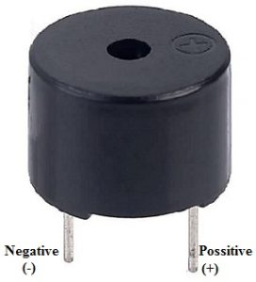

**Fig 3.5 Buzzer**

**Specifications :**

1. Operating voltage ranges from 3V to 24V DC
2. The supply current is below 15mA.
3. The frequency range is 3,300Hz.

**3.2.5 DC FAN**

A DC fan works pretty much on the same principle as the DC motor. A DC motor uses an internal arrangement of magnets with opposing polarity. As current passes through the coil around this arrangement, a strong magnetic field is produced. This magnetic field then creates a torque that causes the motor to rotate. Fig.3.6 shows the DC fan

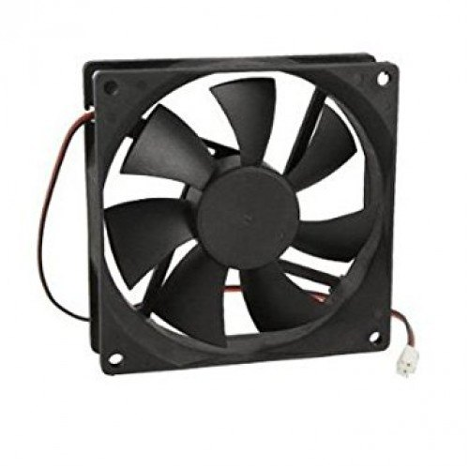

**Fig. 3.6 DC Fan**

**Specifications :**

1. Operating Voltage : 12V
2. Speed: 3000 RPM

**3.2.6 IRF530 MOSFET**

**IRF530** is an N-channel MOSFET designed for high-speed and high-power applications. It is compatible to sustain 14 A of continuous current with 100 V voltage. In pulse mode, it can drive a load up to 56 A. In this series, there are other transistors available with slightly different specifications like IRF531, IRF532, and IRF533. Fig.3.7 shows typical IRF530 MOSFET.

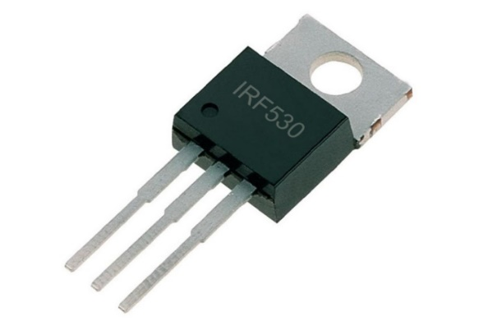

**Fig. 3.7 IRF530 MOSFET**

**Specifications :**

1. Transistor Polarity: N-channel
2. Fast switching
3. On-state resistance: 0.16Ω

**3.3 CALCULATIONS**

To measure gas concentration in ppm. Following steps has been followed.

i) Fig. 3.8 shows the sensitivity characteristics to different gases. From this we can observe that two parameters are used to form these curve. The concentration of different gases is expressed in ppm with respect to Rs/Ro value. X axis represents gas concentration in ppm while y- axis represents. Rs represent resistance of the sensor and Ro represents the resistance of the clear air.

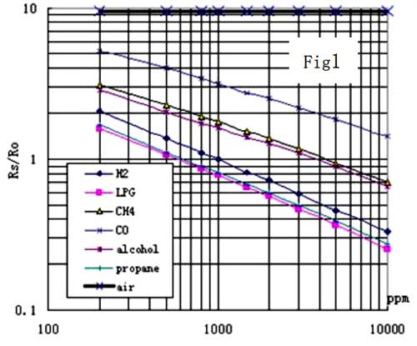

**Fig. 3.8 Sensitivity Characteristics of the Gas sensor**

By determine the value of Rs/Ro ratio of gas we can compare with the curve of a corresponding gas. It involves two steps; the first one is determination of Ro that is the resistance of the surrounding air. The Ro is determined by dividing Rs that is sensed resistance of the surrounding air with the Ro that is resistance of the clear air which is 9.5 for MQ2 gas sensor.

∴ Ro = Rs of the surrounding air / Ro of the clean air …….(1)

The Rs is determined using following equation:

∴ Rs = (Vc/VRL-1)×RL (from data sheet) .......(2)

Finally the ratio that is Rs/R0 is determined. It describes the behaviour of the sensor at different gas concentration.

In the logarithmic graph, RS is the sensing resistance during the presence of a particular gas. While R0 is the sense resistance in clean air. This sensor is designed to detect H2, LPG, CH4, CO so this sensor resistance will change depending on the concentration of H2 or LPG present in the atmosphere.

Let's take an example of the LPG curve which is the pink one and see how we can calculate the slope of the curve, for that lets start with the X and Y coordinates that is 200 and 1.8 approximately So, the first data point from the logarithmic scale is (log200, log2) which is (2.3,0.0.255). The point for the ending curve is X1 and Y1 that is 1000 and 0.18 that becomes (log1000, log0.18) thus it becomes (4, -0.744). To get the slope of the curve, the formula is

= (Y1 – Y) / (X1-X)

= ( -0.744 – 0.255 ) / ( 4 – 2.3 )

= -0.587

That's how we can calculate the slope for this sensor.

To calculate output voltage,

Rs = (Vc-RL)/Vout + RL

i.e Vout = (Vc + RL)/(Rs+RL)

where,

Vc = Input Voltage ( in this case 5V )

Vout = output voltage

RL = Load resistance (20K)

Rs = Measured change in resistance when gas is detected ( 1K )

Vout = ( 5+ 20000 )/ ( 1000+20000)

=0.95 V

**3.4 CIRCUIT DIAGRAM**

The Fig.3.9 shows the circuit diagram gas detection and accident prevention system.

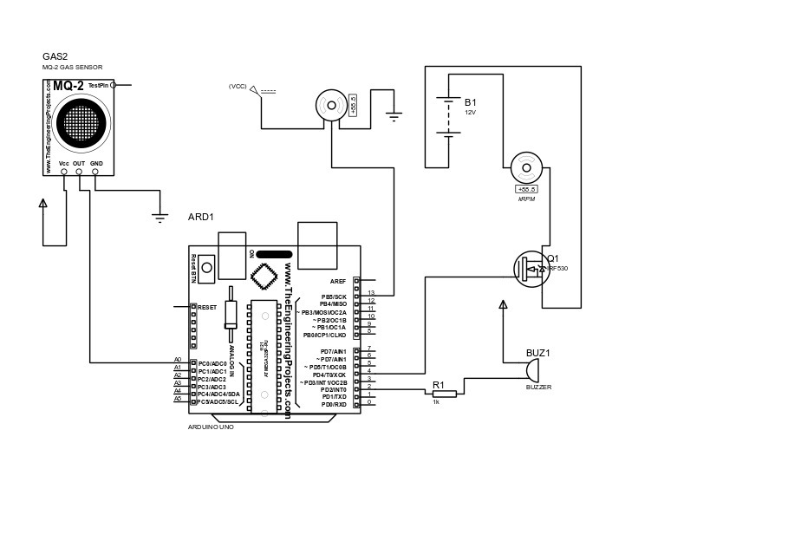

**Fig. 3.9 Circuit Diagram of gas detection and accident prevention system**

**3.4.1 Interfacing Diagrams and Tabulate interfacing pins and explanation**

**1. Interfacing MQ 2 Gas Sensor with Arduino**

Fig.3.10 shows the interfacing og MQ 2 Gas Sensor with Arduino

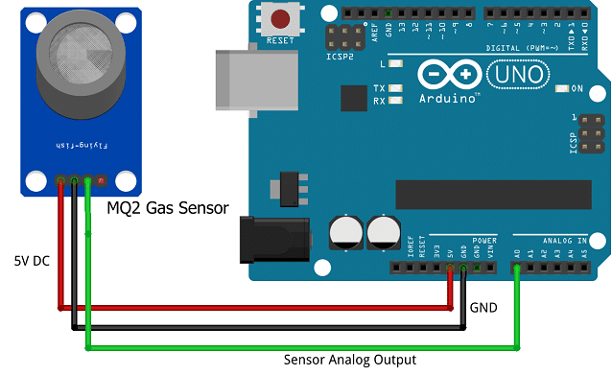

**Fig. 3.10 Interfacing Diagram of MQ 2 Gas Sensor with Arduino**

**2. Interfacing of Servo Motor with Arduino**

Fig.3.11 shows the interfacing of servo motor with Arduino

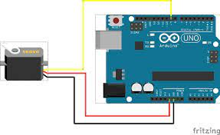

**Fig. 3.11 Interfacing Diagram of servo motor with Arduino**

**3.5 FLOW CHART**

Fig. 3.5 shows the flowchart of gas detection and accident prevention system.

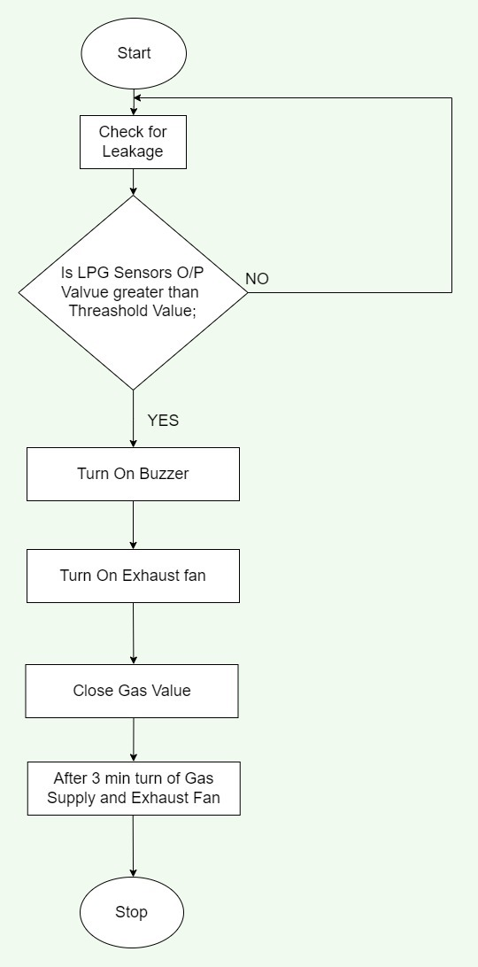

**Fig. 3.12 Flow Chart of the gas detection and accident prevention system**

**3.6 ALGORITHM**

1. Power ON the system.
2. Compare the LPG sensor's value with the threshold value.
3. If the sensed value is greater than the threshold value then turn ON the Buzzer and the exhaust fan by enabling the port.
4. Rotate the stepper motor.
5. If the sensed value is less than the threshold value then sense again.

**CHAPTER 4**

**RESULTS AND DISCUSSIONS**

**4.1 SIMULATION RESULT**

The simulation is done in Proteus 8 Professional software. A toggle switch is used to show gas is detected. As the gas is detected buzzer will start producing sound, servo motor will rotate and exhaust fan will be automatically start. Fig. 4.1 shows the simulation of gas detection and accident prevention.

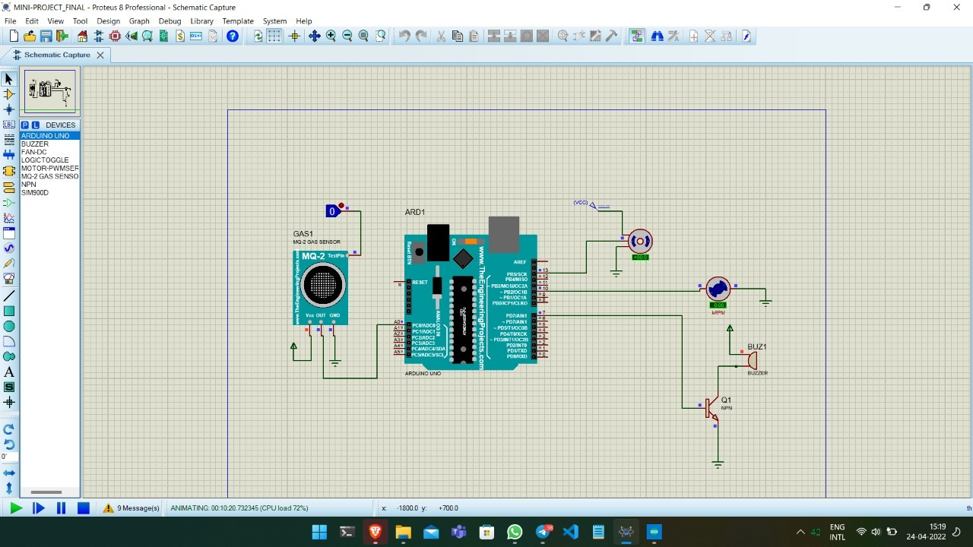

**Fig. 4.1 Simulation Result of gas detection and accident prevention system**

**4.2 HARDWARE RESULT**

As the MQ 2 sensor senses the gas greater than threshold (200ppm) it will send signal to Arduino Uno. Further the microcontroller sends the signal to externally connected devices such as buzzer, servo motor, fan. Buzzer will produce beep sound along with that servo motor rotates indicating gas valve is closed and exhaust fan will also start rotating. Fig.4.2 shows the hardware result of gas detection and accident prevention system.

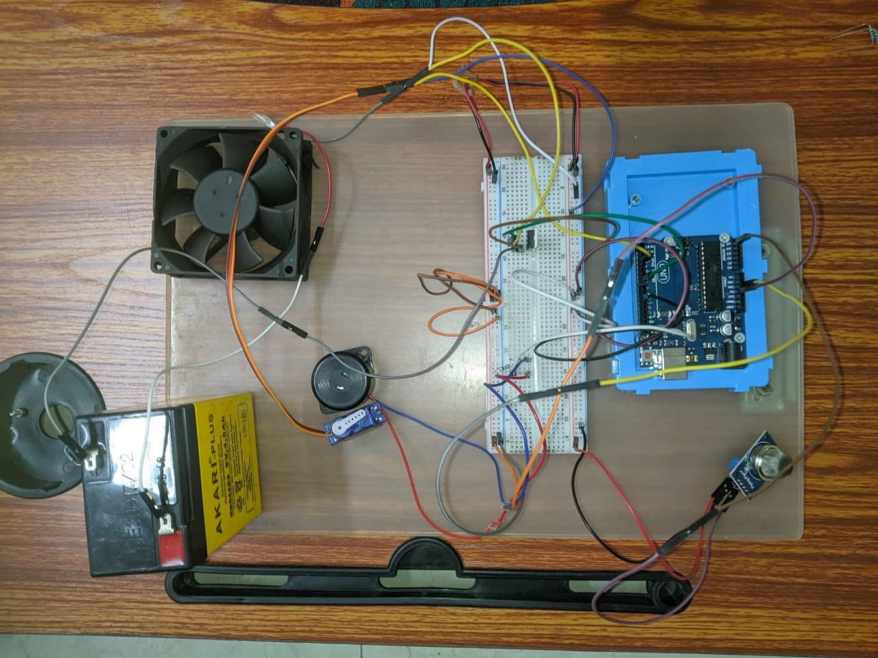

**Fig. 4.2 Hardware Result of gas detection and accident prevention system**

**4.3 DIFFERENCE BETWEEN SIMULATION AND ACTUAL HARDWARE**

1. MQ 2 gas sensor is a analog type but in simulation it acts as a digital type.
2. We are using toggle switch to show gas is detected in simulation.
3. In simulation we needed npn transistor to turn on buzzer while in actual hardware we needed register
4. In simulation we do not require MOSFET for fan but in actual hardware it is required.

-

**CHAPTER 5**

**CONCLUSION AND FUTURE SCOPE**

This chapter gives information about conclusion and future scope of proposed system.

**5.1 CONCLUSION**

This project meant for a new approach for gas leakage detection system at a low concentration. The leakage is detected with the help of MQ-2 gas sensor. Sensor sends signal to microcontroller. In the next step microcontroller sends an active signal to other externally connected devices. This system can be implemented for detecting various gases either in domestic area such as places of educational institutions, residential and industrial areas which avoids endangering of human lives. This system provides quick response rate and the diffusion of the critical situation can be made faster than the manual methods. The simulation is done successfully on Proteus 8 Professional software.

**5.2 ADVANTAGES**

* High sensitivity to LPG, iso-butane, propane.
* Small sensitivity to alcohol, smoke.
* Fast response.
* Stable and long life.

**5.3 DISADVANTAGES**

* The life time of gas sensor is depending on the type of gas to be detected.
* The gas will flow only after the safety valve is opened.

**5.4 FUTURE SCOPE**

Gas Detection and Accident Prevention System can be further enhanced by using GSM to send the alert messages to user, which supports another real-time application. Form industrial sector, the data collected by the mobile application is beneficiary and used for data analytics. The integration of other sensors like temperature, pressure sensors etc. makes the system as a home automation project.

**CHAPTER 6**

**REFERENCES**

**REFERENCES**

1. V Suma, Ramya R Shekar, Kumar A Akshay , **“** Gas leakage detection based on IOT ”, *International conference on Electronics, Communication and Aerospace Technology* (ICECA), 1312-1315, 2019

2.Ashish Shrivastava, Ratnesh Prabhaker, Rajeev Kumar & Rahul Verma, “ GSM Based Gas Leakage Detection System ” , *International Journal of Emerging Trends in Electrical and Electronics* (IJETEE – ISSN: 2320-9569)) , 2016

3.Ankit Sood, Babalu Sonkar, Atul Ranjan and Mr. Ameer Faisal, Microcontroller Based LPG Gas Leakage Detector Using GSM Module ”, *International Journal of Electrical and Electronics Research* 3 (2),264-269,2015

4. Prof.M.Amsaveni, A.Anurupa, R.S.Anu Preetha, C.Malarvizhi, and M.Gunasekaran “GSM based LPG leakage detection and controlling system”, *The International Journal Of Engineering And Science* (IJES ISSN: 2319 – 1805)), 2015

5.Anusha, Dr. Shaik Meeravali, “ Detection Of Gas Leak And Its Location Using Wireless Sensors ” *International Journal of Engineering Research & Technology (IJERT)*

Vol. 1 Issue 9, November- 2012